# CRESCENTVIEW SCHOOL

# STUDENT HANDBOOK



**“Dedicated to the Pursuit of Excellence”**



**Mr. Doyle Moar, Principal**

**Mrs. Suzanne Calder, Vice-Principal**

**751 Crescent Road East**

**Portage la Prairie, MB, R1N 0Y2**

**P: 204-857-3474 F: 204-239-5930**

**http://www.plpsd.mb.ca/cvs/**

Facebook: Crescentview School

Instagram: @cvsadministration

The purpose of this handbook is to acquaint students and parents of Crescentview School with its personnel, facilities, instructional goals, school programs, standards and evaluation, school practices and procedures and to provide any information that may be of interest and useful to both students and parents. Active involvement in your child's education is important. A cooperative effort between the home and the school is essential to help ensure that your child achieves to the best of his/her ability.

**MISSION STATEMENT**

At CVS, we create an inclusive culture of learning where all students are supported as they develop as responsible, resilient, and lifelong learners.​

**VALUES**

* Honesty
* Commitment
* Dignity
* Cooperation
* Compassion
* Equality

**AT CRESCENTVIEW SCHOOL, WE BELIEVE**

• our role is to educate and partner with staff, students, family and community.

• in respect for each other, self and the environment.

• communication is essential.

• that children develop respect for learning (work ethics/value of education).

• students need varied learning opportunities to achieve goals in life.

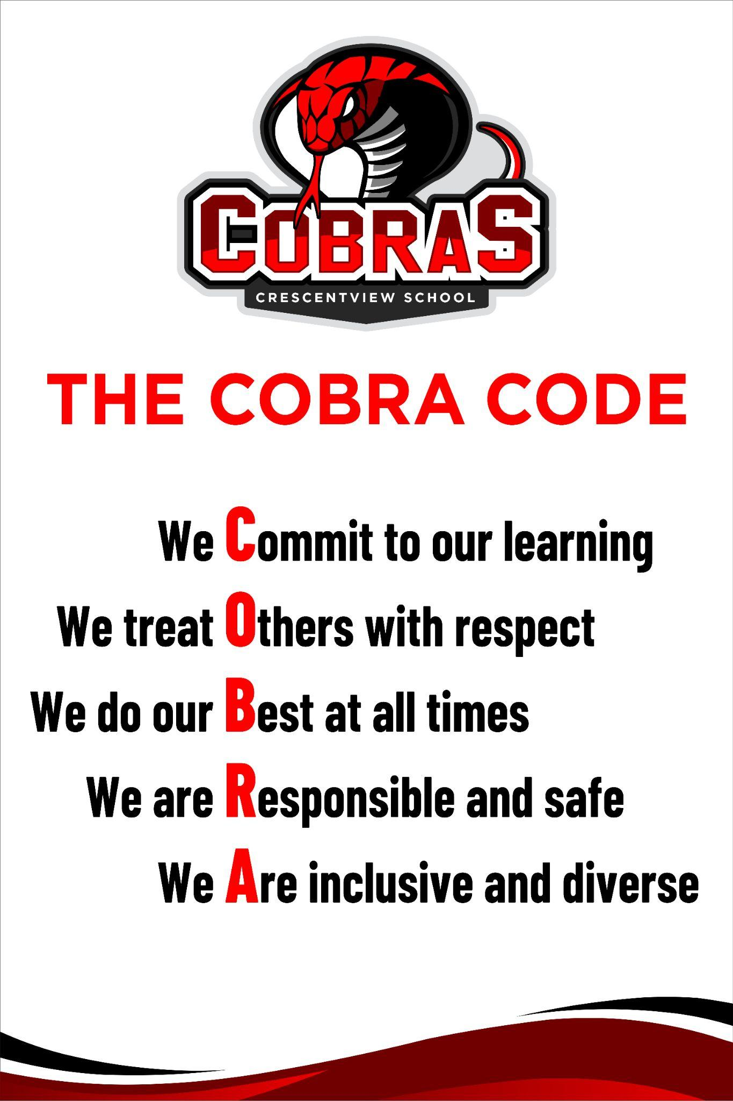

**LEARNING**

• Learning occurs best when students are actively involved and enjoy what they are doing.

• Learning is a lifelong process that includes all facets of an individual’s growth and is not necessarily school based.

• Learning should take place in a safe environment (physical, social and emotional)

• Learning is a co-operative effort involving school, family and community.

• Learning is facilitated when subject matter is presented in many different ways.

**TEACHING**

• Teaching should be at the students’ level.

• Teaching should be a shared process.

• Teaching facilitates the learning process.

• Teaching should take place in a safe environment (physical, social and emotional).

• Teaching involves skill and flexibility.

**GOOD SCHOOL CITIZENSHIP**

You should:

a) be courteous and fair at all times

b) build your reputation for personal responsibility

c) complete your lessons properly each day

d) take pride in your scholastic achievement

e) take an active part in your school

f) be a good sport

**SCHOOL WIDE EXPECTATIONS OF STUDENTS**

1. I am expected to show consideration, courtesy, and respect to others and their property.

2. I am expected to be responsible for any missed assignments due to tardiness, truancy or illness.

3. I am expected to walk quietly and safely to, and from all activities following the directional arrows on the floor and in an orderly manner.

4. I am expected to avoid the use of profane and inappropriate language and gestures.

5. I am expected to wear clean, dry footwear in the school. If I have boots or wet footwear I will remove or clean them. I will put on suitable footwear for use in school. Fire regulations state that students should always have footwear on at all times.

6. If I remain at school for lunch, I am expected to eat lunch in my classroom only and behave appropriately by showing due respect to property and to others.

7. I am expected to remove headgear (ball caps, toques, hoods, etc.) upon entering the school.

8. If I must leave the school during the school day, I will notify my teacher and sign out at the office. When coming in late, I am to report to the office staff to sign in on my arrival at school.

9. I am expected to leave school promptly at dismissal time, unless involved in a supervised activity, and report home or to a location determined by my parents or guardian.

10. I am expected to treat all school property (walls, desks, lockers, books, etc.) with care and respect and if I do not I am expected to pay for the damage.

11. I am expected to be in my designated classroom during class time. To leave the room, I require the teacher's permission.

12. I am expected to report any vandalism or damage of school property to the school office or classroom teacher immediately upon discovery.

13. I am expected to keep all tobacco products, and/or lighters, at home and not have or use them on school property. This includes e-cigarettes and vaporizers (vapes). The schools in Portage are all smoke free and violations of this policy are treated seriously.

14. I am expected to avoid inappropriate or excessive physical contact while in the school and outside. I will keep my hands and feet to myself.

15. I am expected to use school technology devices respectfully and appropriately. I will not have my personal cell phone or device during school hours.

16. I am expected to behave responsibly and appropriately on the school premises, on the way to and from school, on out-of-school activities that are part of the school program; and while traveling on a school bus or in a vehicle being used as part of a school program.

16. I am expected to be diligent in pursuing my studies, attend school regularly and punctually, cooperate fully with everyone authorized by the school to provide educational programs and other services, comply with the rules of the school, account to my teachers for my conduct and respect the rights of others at all times.

**PARENT EXPECTATIONS**

Parents are expected to be partners with the school and the division in achieving a high-quality education for their children in a safe and secure environment by:

• Being aware of the school and division’s policies concerning standards of behaviour, attendance and procedures for dealing with inappropriate behaviour.

• Communicating with the school staff the scholastic achievement and personal deportment of their children/wards at scheduled parent-teacher conferences and on other occasions as requested by either party.

• Being supportive of good learning through a home environment that encourages good study habits, completion of homework and enthusiasm for learning.

• Encouraging students to be respectful of other students, staff and school property.

**STAFF EXPECTATIONS**

Staff is expected to carry out their responsibilities by:

• Setting and modeling good examples of behaviour, demonstrating respect for authority and due process and being respectful of parents, colleagues and students.

• Acquiring the skills and techniques necessary to deal effectively with a wide range of student achievement and behaviour needs.

• Establishing and maintaining a pleasant, safe, orderly and respectful learning environment throughout the school.

• Communicating information about student progress and achievement to students and parents.

• Communicating and sharing information with staff and administration.

**CELL PHONES AND DEVICES AT SCHOOL**

* Personal cell phones, gaming devices, ipads, tablets etc. are **NOT PERMITTED**. **If brought,** **the school will not be responsible if they are lost or stolen.** They should be kept locked in your locker.
* **Social Media:** Students are reminded to be responsible about social media activity. Students and parents are encouraged to share social media concerns with administration in a timely fashion. ***Block & Report***
* See attached letter.

**CELL PHONE POLICY**

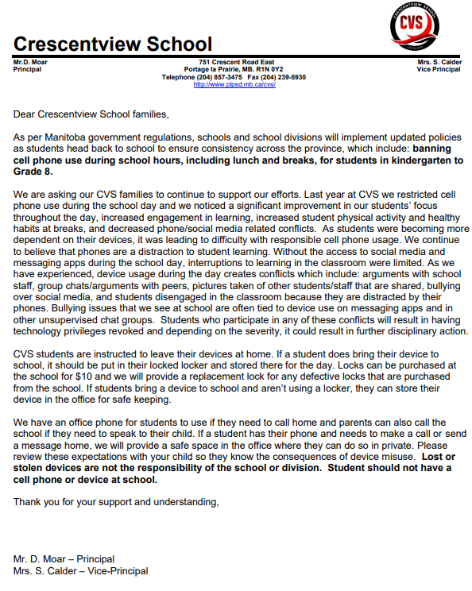

**POSITIVE BEHAVIOR INTERVENTION AND SUPPORTS (PBIS)**

★ PBIS is

* an approach that schools use to improve school safety and promote positive behaviour.
* A positive behavior program to make our school a safe, responsible, and respectful place!
* Clear school-wide expectations with consequences and rewards
* Focus is on teaching and reteaching behaviours
* Recognition and celebration for successes
* What does PBIS do for Students?
* Teach them appropriate behaviours - Lessons throughout the year, reteaching opportunities
* Recognize and praise their positive behaviours - Rewards, opportunities to participate in special events, school swag, etc.
* Creates consistency amongst the school environment
* Creates a fun, positive atmosphere!
* How does PBIS work?
* Students follow the same rules and expectations at CVS.
* These will be on posters throughout the school.
* When students follow the rules and expectations, they are recognized.
* When students do not follow the rules, there are planned consequences to help them get back on track.
* Everyone is on the same team!

★ PBIS calls on schools to teach students about behavioural expectations and directly teach social emotional skills just as they would teach any other subject.

*Crescentview will be in year 2 of the PBIS programming for the 2025-2026 year.*

**Crescentview PBIS Behaviour Matrix - School Wide Expectations**

| **Behaviours** | **Hallways** | **Playground** | **Washrooms** | **Lunchrooms** | **Entrance/**  **Exit Areas** |
| --- | --- | --- | --- | --- | --- |
| **Respectful** | **We hold the door open for others.**  **We enter calmly & quietly.**  **We remove wet, dirty, footwear.**  **We remove hats & hoods.** | **We are quiet in the hallways.**  **We admire displays and signs with eyes only.**  **We keep our hands off other students' lockers.** | **We keep the space clean & use the garbage cans**  **We give others privacy & space.** | **We share equipment and include others.**  **We play fair and show good sportsmanship.**  **We use school appropriate language.**  **We put garbage and recycling in the bins provided.**  **We listen to all adults at first request.** | **We use indoor voices.**  **We wait patiently to be dismissed.**  **We listen to all adults at first request.** |
| **Responsible** | **We enter & exit through our assigned door.**  **We wait with our class for an adult to invite us in or dismiss us.** | **We keep our hallways clean and clear.**  **We put away our belongings in our lockers.**  **We are in our class on time.** | **We use the washroom in a timely manner.**  **We return to class when we leave the washroom.** | **We care for and return equipment.**  **We line up as soon as the bell/whistle goes.**  **We stay in our designated area.**  **We speak to an adult on duty when we need help.** | **We stay in our own seat.**  **We clean up after ourselves.** |
| **Safe** | **We keep the doorways clear.**  **We keep our hands & feet to ourselves.** | **We keep our hands and feet to ourselves.**  **We walk on the right hand side, single file facing forward.**  **We patiently wait our turn to get our things from our locker.** | **We wash our hands.**  **We report any concerns to an adult.** | **We use equipment appropriately and safely.**  **We keep our hands and feet to ourselves.**  **We report injuries to an adult immediately.**  **We dress for the weather.** | **We ask a staff member for permission to leave the room.**  **We eat our own food.**  **We notify staff of a change in lunch plans.** |

**CANTEEN**

● Students requesting lunch from the canteen must send their order to the canteen with the class order in by 9:30 a.m. Students who forget can talk to their homeroom teacher or administration. Late students come to the office for attendance and can go immediately to the canteen and place an order.

● **Students who did not order in the morning may not be allowed to order food items from the canteen.**

**STUDENT FEES**

* $30.00 for school supplies at the beginning of each school year. Basic supplies will be purchased by the school for each homeroom.
* Locks $ 10.00
* IA/Home Ec. $ 30.00
* Band $ 40.00
* Guitar $40.00
* Art $ 40.00

**STUDENTS’ PERSONAL SUPPLIES**

Kindergarten to Grade 8 parents provide the following (please label all personal items with permanent marker):

* water bottle
* Gym clothes (optional)
* Indoor/gym shoes
* Backpack
* Lunch kit
* Pencil case
* Kindergarten only - extra set of clothing

**NOON HOUR REGULATIONS**

* Lunch is to be eaten in homerooms
* Kindergarten to Grade 8 students staying for lunch will remain in their areas until dismissed outside.
* Students going home for lunch must do so immediately – not loitering in the hallways, washrooms or entranceways
* Cleaning Desks at Lunch: If you stay for lunch, a staff member will assist students in spraying and wiping desks after eating. Avoid putting your food on a really dirty desk. Spray and paper towel provided in your homeroom if needed. A clean desk ensures safety.
* Any students that stay for lunch regularly are **not** to leave the school grounds during the noon/recess break unless they are signing out at the office with parental permission.
* Students who are uncooperative/defiant during noon hours may lose noon hour privileges and will have to find other noon hour accommodations which may include being picked up by a parent/guardian for the lunch period.
* Throwing any articles including food is not allowed and may result in the suspension of the privilege to stay at school for lunch.
* The classroom must be tidy before dismissal.
* Directions by the lunchroom supervisor are to be followed at all times.
* Students leaving the school grounds for lunch should not return until the lunch break is over.

**RECESS/BREAKS**

* There are no inside bells to signal the start of breaks. Students are dismissed by their teacher or supervisor. Students need to head outside for recess as soon as they are dismissed. Staying in the classroom is not permitted.
* Note: If you are found to be hiding or loitering in the hallways, you may be spending time in the office during breaks or being supervised by an adult during recess. Gr.7 and 8 students will have their morning break contained in their classroom. They are not permitted to go to other classrooms or to be in the Gr. K-4, 5 and 6 areas. Grade 7 & 8 students are expected to go outside for their afternoon break.
* **No student may leave the school grounds during the morning or afternoon breaks**
* **Movement in hallways and classrooms:** Running, pushing, shoving, bumping and play fighting in hallways and classrooms will not be tolerated: Hand and Feet to yourself/Inappropriate Displays of Affection: Do not lay hands on other students, take their hat off if worn outdoors, or knock it off, no tackling/pushing/shoving etc. Students are not to engage in hand-holding, hugging, or kissing in the school or on school grounds (recesses, lunchtime etc.)
* When moving in the hallways, walk on the right- hand side, single file. **Be mindful of classes in session when you are in the hallway and keep the noise level down. Be respectful.**

**STUDENT ILLNESS**

* When a student is too ill to function well in the classroom parents will be contacted to pick the student up. Please be advised that we do not have a medical facility or qualified staff to look after your child at school. If your child is sick, please keep them at home or make alternate arrangements.

**SAFETY GUIDELINES FOR STUDENTS**

* **Injuries**: If you hurt yourself or get hurt, you need to tell an adult. In some cases, you will need to come to the office. Depending on the injury, your parent/guardian may be called by the office, or you may be asked to call them to let them know. If you see a student get injured or they tell you they did, you need to report it to the office. Don’t assume your teacher or another adult always knows. Should you need to go home or get checked out, it is appreciated if your parent/guardian calls the school to let us know how you’re doing.
* **Bullying:** There are often concerns about “bullying”. Please be advised that we have Anonymous Reporting—this can be accessed by a QR code. Info. will be on posters around the schools and will be sent to your parent/caregiver in an e-mailed handbook/newsletter. These will be taken seriously and dealt with.

You should know, however, that “bullying” is not when someone, whether you know them or not, calls you a name once or twice. It is considered bullying when you specifically, are targeted by someone and bothered over a period of time. Also, bullying is not when two friends have a disagreement. If you feel your friend is bullying you, you might want to reconsider the friendship. If you go to the office with this kind of concern, unless you are prepared to cut ties with this friend, it will be treated as normal conflict. In the case of bullying, don’t be a bystander-if you do see someone in your class getting picked on, please tell your teacher, EA, the office staff, or another adult in our building. Or report anonymously.

* **”Snitching”:** Some students won’t tell an adult that someone is bothering them. However, sometimes that other student will report you the one time you say or do something back to them and if you have ever done or said something to that student, you may be surprised to find yourself in trouble, even though it was only one time, and yet that person has been bothering you A LOT. You will feel that this is unfair. To avoid this kind of problem, you do need to tell an adult if you are being bothered, even if it has only happened once or twice. You may not want anything done right away, but if it continues, the student needs to be spoken to because you need to be left alone.

**WEAPONS/REPLICAS**

* Any weapon, big or small, or a replica of a weapon (a fake-- like a toy/plastic gun/knife etc.) brought to school will result in an automatic 5 day Out of School Suspension. This includes butter knives and steak knives, plastic or otherwise, at lunch, as well as Swiss Army knives, multi-tools, toys…NO EXCEPTIONS. Always a good idea to check your backpack before you come to school…make sure these kinds of toys or items etc.. are not in it!

**ACCIDENT INSURANCE**

* Accident insurance is made available annually to students on a voluntary basis. Details of the plan, instructions covering enrollment procedures, and application forms will be sent home with students from school.

**DRESS CODE**

* We do not have a formal dress code. Please dress appropriately and respectfully for school and learning. Unless your clothing is extremely weather-inappropriate, is unsafe, is offensive/rude, we are not concerned. Any concerns would be addressed privately with students.

**PROTECTION OF PERSONAL PROPERTY**

* Purchase a lock at the office and do not tell anyone your combination. If someone learns your combination, return your lock to the office and a new one will be provided.
* All articles of clothing and footwear should be labeled with the student’s name for easy identification. Your belongings and papers are not to be on the floor in front of your locker, or papers and backpack straps sticking out of your locker. Locker door needs to be closed. Items will be sent to the lost and found or will be thrown out.
* Sums of money and any other valuables should be left in the office for safekeeping. **Never should money or valuable items be left unattended in change rooms…give it to your teacher!** Do not bring large sums of money to school or valuable items to school. Any money your parent/caregiver gives you for things, give to your teacher ASAP.
* Report immediately to the office any loss of personal property.
* **The school will not be held accountable for lost or stolen items if not secured.**

**ADMISSION TO SCHOOL BUILDING IN THE MORNING**

* Students are not to be in the school before **8:30** on any day unless participating in open gym or breakfast program.
* Open gym for students starts at 8:10 am - 8:50 am. Students going to open gym can access the gym through the side gym doors by the basketball court.
* The Breakfast Program will run from 8:30 am - 8:50 am. Students can enter through the front entrance and will be served in the multipurpose room.

**MORNING ROUTINE**

* When you arrive at school in the morning, you will be meeting your classmates outside in your grade’s designated area. All areas are marked with signs or on the field with paint. Admin will send you in if the weather is inclement (raining, blowing snow, extreme cold) at 8:30, no earlier. Doors will open at 8:50 on regular days for students to enter through their assigned doors. Once entering the school, you need to head directly to your classroom and get ready for the day. Please do not wander the hallway or be in other classrooms.

**END OF THE DAY**

* At 3:30, students are not permitted to hang around the school or be in other classrooms after dismissal. Bus students may be dismissed earlier at 3:27 only if there are early buses in which they may be called down. Bus students will be waiting in the bus loop area and students who are getting picked up should be in the parent pickup/drop off area. If you are walking home, you are not permitted to wait outside with the bus students or to linger at the parent pick up side.

**LATES**

* Late to school: If you are late, you need to come to the front entrance, sign in at the Office and report to your class. If the class you have arrived in time for is not your homeroom teacher, let your homeroom teacher know you have arrived before you head to class. If you don’t, and the Office doesn’t know that you’ve even arrived, you will be marked absent and there may be a call home. Always sign in and see your homeroom teacher as soon as you can so they know you are here

**EARLY DEPARTURE**

* The parent/guardian must enter and exit through the front entrance and sign-out their child at the main office
* Students Signing Out: If you have an appointment or your parents are planning on picking you up from school earlier than 3:30, unless it is over the lunch hour, you are expected to “sign out” at the Office. You need to provide a note saying that you are leaving early/have an appointment. Parents may be called if you do not provide a note and/or you may not be permitted to leave.

**CLASSROOM HOUSEKEEPING**

* Students are requested to hang up their labeled outdoor wear in the lockers provided
* Lockers are school property and may be inspected by teachers or administration for any reason. You will need to have a lock for your locker (Gr. 5-8 is advisable, but K-4’s can have one if they like. We also have 1-digit locks for students who struggle to use a lock and need to use a lock.) Key locks are not advisable—the keys are often lost and the lock needs to be cut off. The combination must be forwarded to your homeroom teacher. Your locker door must be kept closed and preferably locked at all times, so others can’t go into them.
* Jackets/boots/backpack/lunch are usually the only items that are kept in your locker. Locker decorating: Feel free to decorate, but it needs to all be removed at the end of the year. Please do not use a permanent marker, pen, or pencil on the locker. You will be responsible for removing it or may be asked to pay for any damage to the locker. No stickers, please, as these are hard to remove.
* Students are discouraged from sitting on desktops, putting their feet on seats of chairs, and from teetering on chairs.
* Students must not mark or deface school property or books in any way. Do not write on desks. Students detected willfully damaging school property must pay for such damage.
* At afternoon dismissal, texts and notebooks should be stacked neatly in the book compartments.
* **While in the gym, all valuables must be left with the Phys. Ed. teacher.**
* Wet footwear is to be removed upon entering the building.
* **Energy Drinks:** These are not good for you and are not allowed at our school.
* Sunflower Seeds: These are not allowed at our school or on field trips/events.

**BICYCLES, SKATEBOARDS, ROLLERBLADES & SCOOTERS**

* When used for transport to and from school, they must be carried while on school property and then placed in lockers or in a safe location.
* Rollerblades, roller shoes or ‘heelies’ are not to be worn on school property.
* The school will not be responsible for any lost, stolen or damaged equipment that students bring to school.
* Bike racks are to be used and students **must** lock their bikes.
* Students not following the rules of biking will be asked to leave their bikes at home.

**MESSAGES TO STUDENTS**

* Parents are requested to send messages to be delivered through the school office. However, in the event that a child must receive a message, particularly about alternate transportation or childcare arrangements, contact must be made by 3pm.
* We cannot guarantee delivery of a message near the end of the day. It is recommended that you send your message before 3:00 pm.
* If buses need alternate directions (including taking extra students), it is absolutely necessary for the **parent to contact the bus garage** well in advance. There is an answering machine at the bus garage to take early morning calls.

**CHANGE OF HOME ADDRESS OR TELEPHONE NUMBER**

* **A change in telephone numbers or an email address must be reported immediately for safety/health reasons.**
* In the case of a legal change of name of the student, or a change in custody of the student, please notify the administration of the school immediately. In addition, the school should be advised of the presence of a non-custodial parent and should be provided with legal documentation of **any court orders limiting** the rights of a non-custodial parent.
* It is imperative that the school can contact parents at all times, so please ensure that parent phone numbers are correct **and cell phones are activated.**

**VISITORS ENTERING SCHOOL**

* Throughout the Portage la Prairie School Division, signs are posted on external doors of schools **requiring all visitors to report to the office on arrival.**
* Like teachers and support staff, the expectation is that parents/visitors in the school and on school grounds model respectful behaviour.

**PROCEDURE FOR CONTACTING TEACHERS ABOUT CONCERNS**

* Step #1 - parents contact the teacher directly and express any concerns.
* Step #2 - the teacher can respond and address the concern with the parent.
* Step #3 - if the concern persists after a reasonable period of time for resolution has elapsed, then the parent can make an appointment with administration for further discussion.
* Polite respectful behaviour by all adults involved is expected and requested at all times.

**PETS AT SCHOOL**

* Pets are not allowed in the school or on the school grounds unless permission has been granted by the administration. Pets cannot be brought for a classroom activity such as "Show and Tell” due to allergies and safety issues.
* Division Policies will be reviewed in exceptions where service animals are present in Student Specific Programming.

**STAFFING 2025-2026**

PRINCIPAL Mr. D. Moar

VICE-PRINCIAL Mrs. S. Calder

KINDERGARTEN Mrs. M. Hauser EY MUSIC Mrs. S. Holmes

GRADE 1M Ms. J. Mikolayanko MY MUSIC Ms. J. Waines

GRADE 1A Mrs.T. Andrich BAND/GUITAR Mr. S. Preun

GRADE 1BL Ms. Baldwin/Mrs. Lavoie GUITAR Mr. E. Goertzen

GRADE 2H Ms. G. Holmes HOME EC. FOODS Ms. K. Moar

GRADE 2V Mrs. A. Van Damme GRAPHIC ARTS Mrs. S. Larson

GRADE 3P Mrs. S. Patterson INDUSTRIAL ARTS Mr. B. McGowan

GRADE 3B Mrs. A. Boschman TEXTILES Ms. L. Mackedenski

GRADE 3F Ms. M. Farkas EY PHYS ED Mr. K. Botterill

GRADE 4G Mrs. K. Gardiner MY PHYS ED Mr. B. Janz

GRADE 4M Ms. K. MacAulay

GRADE 4P Mr. S. Pynn GUIDANCE Mrs. J. Budz/Mr. A. Martini

GRADE 5K Mrs. A. Klassen RESOURCE Mrs. S. Hewitt/Mrs. T. Pierpont

GRADE 5D Ms. A. Duchnycz SPEECH PATHOLOGIST Ms. H. Harrysingh

GRADE 5B Mr. D. Brooks OCCUPATIONAL THERAPIST Ms. H Hueging

GRADE 6G Mr. B. Graham SCHOOL PSYCHOLOGIST Ms. M. Mutcher GRADE 6M Mrs. E. Moar ADMIN. ASSISTANT Mrs. M. Whincup

GRADE 6C Mr. A. Couvier CLERICAL ASSISTANT Mrs. R. Reynolds

GRADE 7G Mrs. B. Grant COMPUTER TECH Mr. S. Duncan

GRADE 7D Mr. D. Durdle OUTREACH FACILITATOR Mrs. A. Lee

GRADE 7B Mrs. R. Braun LIBRARIAN Mrs. S. Cooper

GRADE 8D Ms. K. Davey

GRADE 8H Mrs. J. Hartnell

GRADE 8B Mrs. J. Bennett

**EDUCATIONAL ASSISTANTS**

* Ms. J. Rodrigues
* Mr. L. Jonas
* Mrs. B. Oke
* Mrs. D. Armishaw (speech)
* Mrs. C. Perry (speech)
* Mrs. H. Patel
* Mrs. N. Hamm
* Mrs. D. Rodd
* Mr. H. Greenslade

**CUSTODIANS**

● Mr. C. Muir – Day Charge

● Mr. R. Gellamucho – Night Charge

* Ms. A. Cooper
* Ms. J. Hrabluik
* Mrs. P. Denman
* Mrs. K. Alford
* Ms. S. St. Goddard
* M. M. Dyer
* Ms. C. Kasprowich
* Mrs. S. Pepper

| **K-8 SCHEDULE** |  |
| --- | --- |
| **Period** | **Time** |
| Opening exercises | 8:57 - 9:00 |
| Period 1 | 9:00 - 9:40 |
| Period 2 | 9:40 - 10:20 |
| Period 3 | 10:20 - 10:55 |
| **Recess** | 10:55 - 11:10 |
| Period 4 | 11:10 - 11:50 |
| Period 5 | 11:50 - 12:25 |
| **Lunch** | 12:25 - 12:45 |
| **Lunch Break** | 12:45 - 1:20 |
| Period 6 | 1:25 - 2:00 |
| Period 7 | 2:00 - 2:35 |
| **Recess** | 2:35 - 2:50 |
| Period 8 | 2:50 - 3:30 |
| Dismissal | 3:30 |

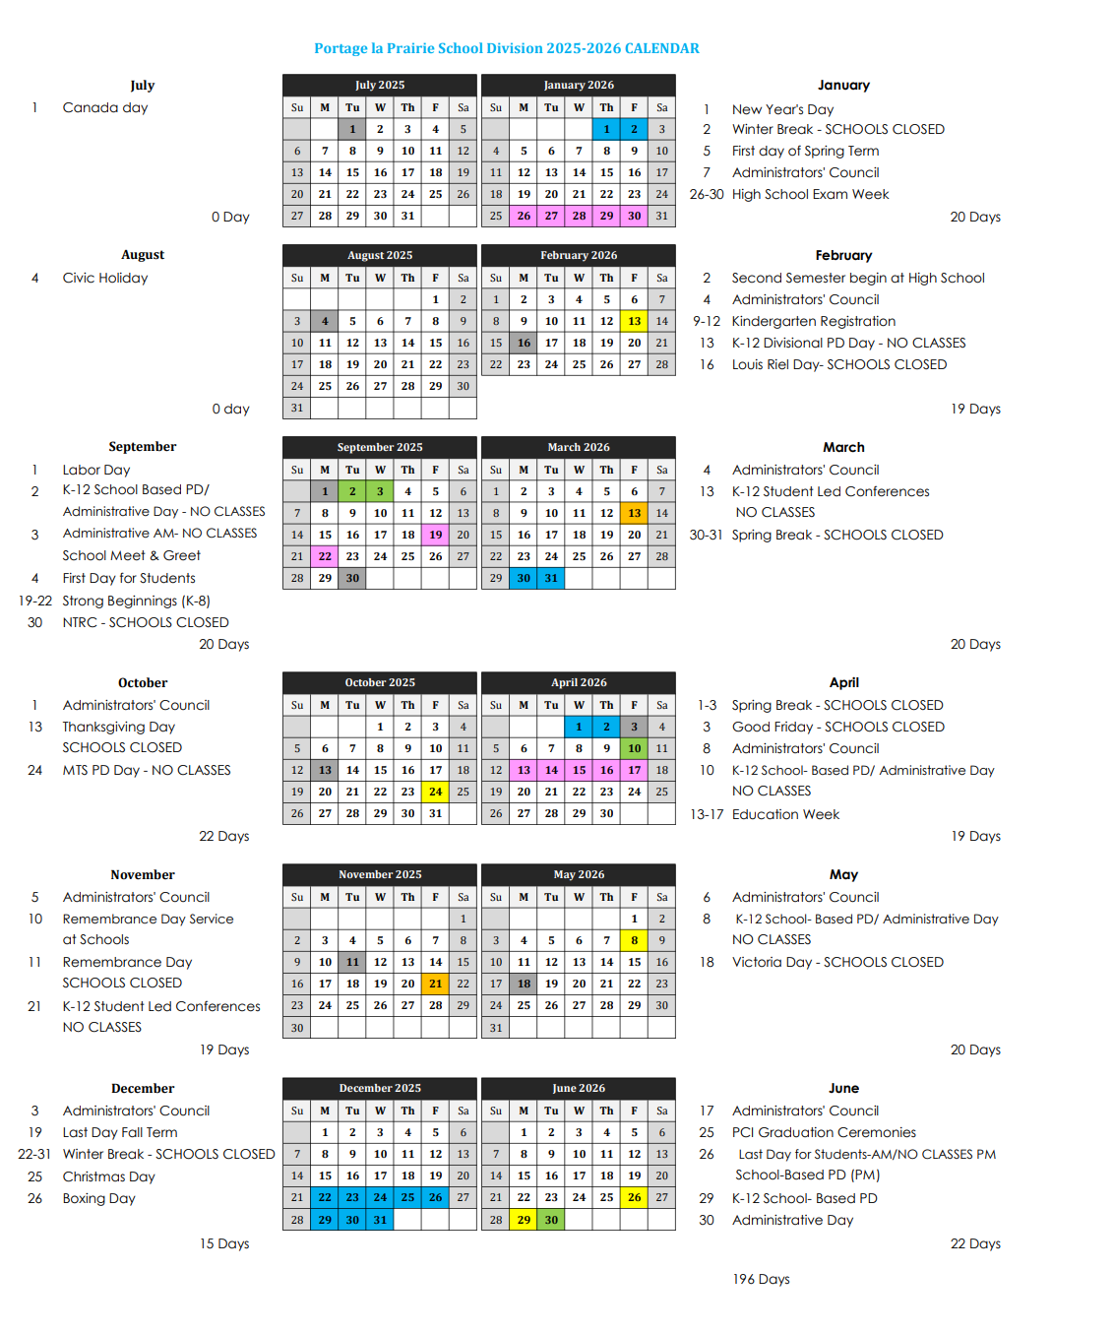

**DIVISION POLICIES**

Please review our Division Policies on harassment, sexual harassment, filing complaints and other policies on the PLPSD website: http://www.plpsd.mb.ca